**Script Writing with Accela**

* **Initial Steps**
  + Create a GitHub account at [www.github.com](http://www.github.com) . Use your City of Mesa email in the account creation.
  + Notify the appropriate administrators of the Mesa DIMES GitHub Repository so that you can be granted access. At the time of this writing, that person is Brian Odell.
* **Recommended Tools – Download and install before continuing.**
  + [GitHub for Windows](https://desktop.github.com/) – This will be used to do the initial download of the DIMES GitHub Repository.
  + [Visual Studio Code](https://code.visualstudio.com/download) – This will be used to write the scripts and synchronize with the DIMES Repository on Github.com.
* **Download the Mesa DIMES Repository on your workstation**
  + Open GitHub for Windows and log in with your GitHub account.

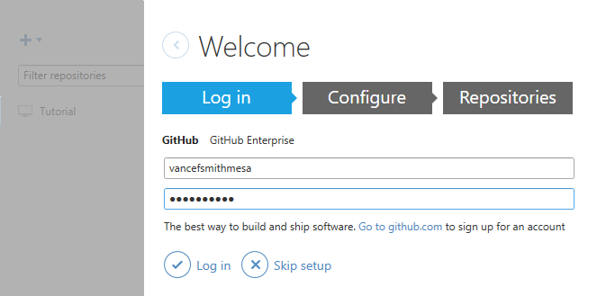

* + 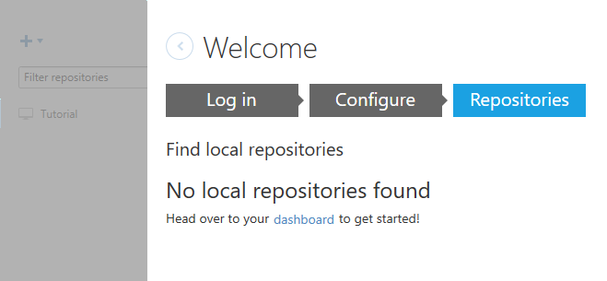When you click the “Configure” button it will quickly notify you that there are no local repositories found. Click the “dashboard” link to continue.
  + 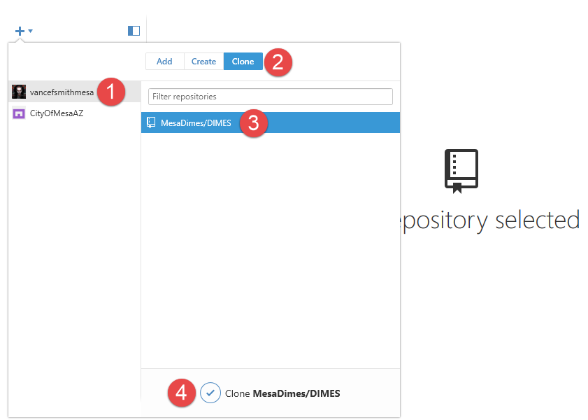Click the following items in the following order to “clone” a copy of the DIMES Repository to your workstation.
  + You will then be prompted to choose a folder where you would want to clone “DIMES” into. It is recommended to go with the GitHub folder that has already been created in your “Documents” folder.  
      
    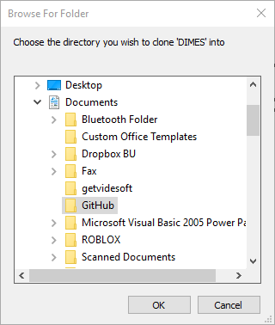
  + You can now close GitHub for Windows. You should now have something similar to the following on your workstation:  
      
    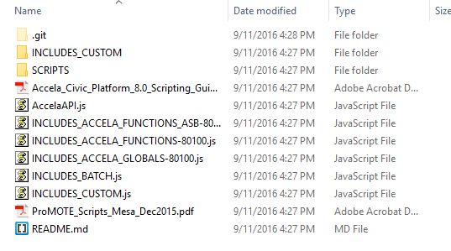
* **Using Visual Studio Code**
  + Click [here](https://appsinside.mesaaz.gov/LearningCenter/ArticleView.aspx?id=42866) to view an article in the Learning Center to learn how to connect to your local DIMES Repository and publish a new or modified script to Accela with Visual Studio Code.
* **Important Concepts**
  + “Record Types”:
* **Needed Links**
  + [Mesa’s Accela Site](https://av.supp.accela.com/): This is Mesa’s Accela site that is to be used for script development and testing. It is recommended to use Internet Explorer for this because of Accela’s use of “Silverlight” in some pages.
    - 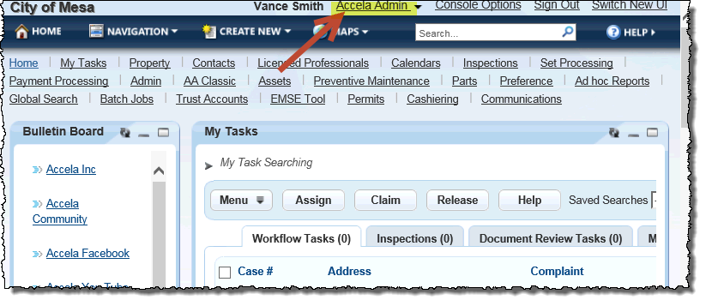Upon opening, switch to “Accela Admin”:
    - Main pages:
      * AA Classic / Event Manager / [Script Test](https://aa.supp.accela.com/admin/eventmanager/index.cfm?fuseaction=ScriptTest&barsel=6b&tagsel=17&menusel=c) : This is where you will test the scripts that you are writing.
      * [EMSE Tool](https://av.supp.accela.com/jetspeed/portal/media-type/html/user/MESA.72.CONSOLE_UTF8_ENCODED/page/default.psml/js_pane/P-150b56398d6-1002d): This is where you will deploy scripts into Mesa’s Accela site.
      * Admin / Setup / Administration / [AA Admin](https://av.supp.accela.com/portlets/silverlight/appLoad.do?mode=adminFramework&title=AA+Admin) : This is where you can research how Mesa’s Accela site has been configured. Most importantly, you can view the various “Record Types” that have been configured. This is essential when working scripts to verify that the script definition from Script Tracker is correct.
      * Admin / Setup / Administration / [Workflow Designer](https://av.supp.accela.com/portlets/commons/workflowdesigner/workflowdesigner.jsp) : This is where you can research the various workflow’s that have been setup for each “Record Type”.
  + [Accela’s SharePoint Site](https://portal.accelaops.com/projects/Mesa/) (open all of these links in Chrome)
    - [Script Tracker](https://portal.accelaops.com/projects/Mesa/Lists/Script%20Tracker/DispForm.aspx?ID=109): This is in Accela’s SharePoint site. Script Tracker contains a listing of the scripts that need to be created for Mesa’s implementation of Accela.
    - [To-Be Documents](https://portal.accelaops.com/projects/Mesa/ToBe%20Docs/Forms/AllItems.aspx): These are the configuration documents that were created by Accela and the customers that are supposed to outline how we are to configure Accela for the City of Mesa.
  + Research Links
    - [Accela Community](https://accela.force.com/success/customercommunityhome): This is a great site to use to look for code and to ask questions. Basically, it is the “Stack Overflow” site for Accela. (open this in Chrome)
    - [ArcGIS Rest Services Directory](http://gisweb.mesaaz.gov/mesaaz/rest/services/Accela): This is the REST documentation for the ESRI REST services that were setup by IT GIS. This can be used to research needed parameters for getting GIS data. Jody Bearden IT GIS is a great resource on how this tool can be used. (any browser can be used)
    - EMSE-API-8.0.2 Documentation: This is a useful listing of some of the classes and functions in the Accela EMSE API.
    - Scripting Guide: This is Accela’s Official Scripting Guide.